
Lesson 7: On the Move
001 Game Creator (Windows only)
VIDEO GAME CREATION
This week: enemies stop standing still. Your job is to make every enemy advance slowly toward the player, and clean up any that reach the bottom of the screen without being shot.
Open your own [YourName]Game project from Lesson 6 - don't start a new one.
Tip: no new assets this week - this is a logic-only lesson.

Setup
- Open your [YourName]Game project from Lesson 6.
- IMPORTANT - fixing a hidden bug from Lesson 6: the enemy Actor Template's "Defeated / Destroyed" trigger currently decreases enemies_remaining whenever ANY copy of the enemy Actor is destroyed, for any reason. That was fine when being shot was the only way an enemy could be destroyed - but this week, enemies can also leave the screen by moving off the bottom, and that must NOT count as a kill. Delete the "Defeated / Destroyed" trigger from the enemy Actor Template entirely - it's being replaced below.

Level 1 - Minimal (MVP)
Every enemy moves slowly downward, toward the player, instead of sitting still. An enemy that reaches the bottom of the screen unshot is removed - and does NOT count toward your win condition, since it escaped rather than being defeated.
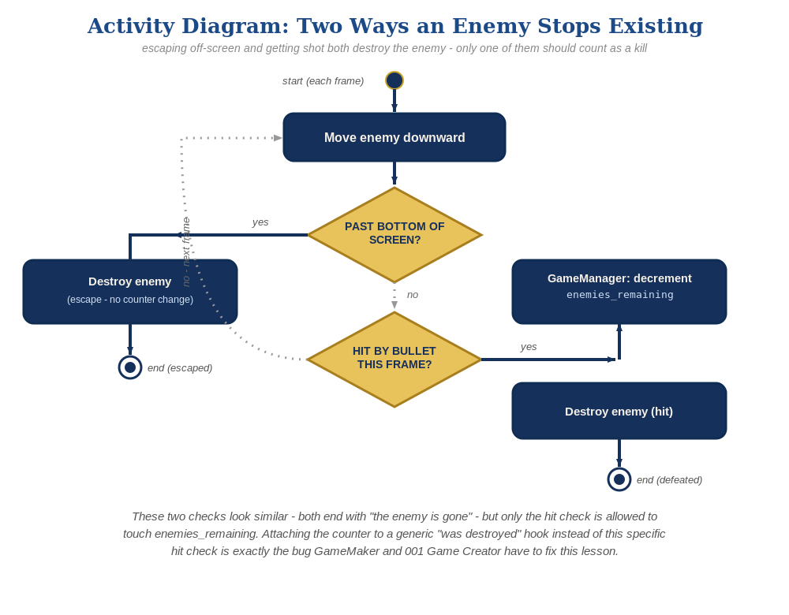
The general escape-vs-hit distinction behind this week's exercise - the same shape in every engine, whatever the exact code or blocks look like.
- On the enemy Actor Template's Automatic Movement settings, tick "Move" and set its direction to Down, at a slow, comfortable speed - the exact same feature the bullet already used for its own upward movement in Lesson 3.
- Add a new Actor Trigger to the enemy Template: "Left/Entered Camera" (the Left case) -> a script with an "Actor – Destroy/Revive Actor" event (Destroy) targeting itself - the exact same trigger the bullet already used for its own off-screen cleanup in Lesson 3.
- On the enemy Template's existing "Collided with actor" trigger, add the win-counter decrement there instead, right alongside the existing Destroy events (code below) - this is the ONLY place enemies_remaining should ever change now.
- Save, then Play/Test and let the enemies drift downward - shooting one should still work exactly as before, and letting one reach the bottom unshot should just remove it, with no "You Win!" message.
enemy Actor Template settings:
Automatic Movement -> Move = true, Direction = Down
enemy Actor Trigger: Left/Entered Camera (Left case) ->
Actor – Destroy/Revive Actor(this, Destroy)
enemy Actor Trigger: Collided with actor (revised) ->
Variable – Modify Value(enemies_remaining, Subtract, 1)
If(enemies_remaining <= 0)
Message Box("You Win!")
Actor – Destroy/Revive Actor(relate, Destroy)
Actor – Destroy/Revive Actor(this, Destroy)
enemy Actor Trigger: Defeated / Destroyed -> deleted entirely

Level 2 - Complete (Alpha/Beta)
A moving enemy can still be shot and destroyed correctly, and an enemy that escapes off the bottom never triggers "You Win!" by accident.
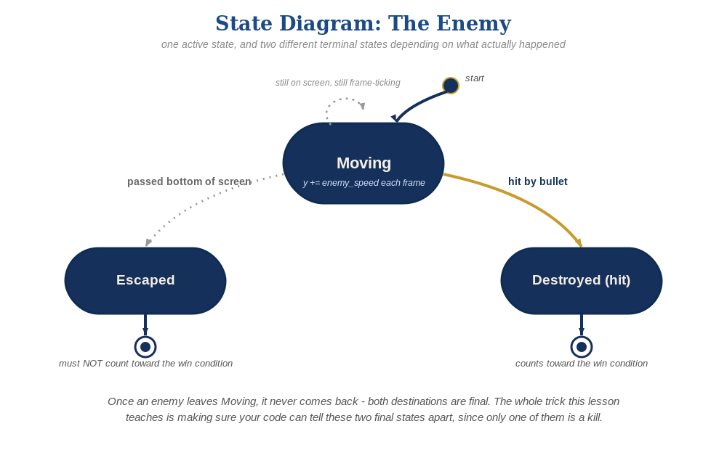
The enemy's two possible endings this week - only one of them should count as a kill.
- Shoot a moving enemy to confirm "Collided with actor" still fires correctly while it's in motion.
- Let at least one enemy escape off the bottom of the camera unshot, and confirm "You Win!" does NOT appear - only "Collided with actor" can ever change enemies_remaining now, and "Left/Entered Camera" never touches it.

Level 3 - Refined (Ready to Publish) - pick any that interest you
- Visual: give a couple of enemy copies a slightly different Automatic Movement speed (per-instance override) so they don't all move in perfect lockstep.
- Structure: keep the enemy Template down to exactly two Triggers now - "Collided with actor" (the fight, including win-counting) and "Left/Entered Camera" (plain escape cleanup). Neither one references the other's job.

If Something's Wrong
- "You Win!" appears even when enemies escaped unshot: this means "Defeated / Destroyed" wasn't fully removed - double check it's actually deleted from the enemy Template, not just disabled.
- Enemies don't move: confirm "Move" is ticked in the enemy Template's Automatic Movement window, with Direction actually set to Down and a nonzero speed.
- Enemies vanish immediately at spawn: confirm "Left/Entered Camera" is checking the "Left" case specifically (exited view), not "Entered" - the wrong case fires the moment they first appear.

Want More?
001gamecreator.com/wiki, Student Resource List > 001 Game Creator

